Join our team! All partnerships can be customized to meet specific needs of your company and are designed to create a mutually beneficial relationship.

Sponsorship Opportunities
Championship Package - $2,500

- Two (2) season VIP passes to the Charlie Annett Hospitality Box and Basketball Track VIP area
- Company VIP Party for up to 8 guests during the football or basketball game of your choice
- Presence on our streaming services, and the Main Street Bank Video Board in ASRC *Men’s and Women’s Basketball 2023-2024 season
- Company name and logo on all printed, social media, email, and website ads
- Recognition at game naming your company as a sponsor
- Opportunity to bring promotional material to VIP area
- Opportunity to create a halftime promotional activity for students/fans
- Banner with company logo at West Family Stadium and ASRC
- Two (2) reserved seats through the Save Your Seat Program near the field during the 2023 Football season. Two (2) reserved seats through the Save Your Seat program near the court during the 2023-2024 Men’s and Women’s Basketball season. This offers you the flexibility to move from VIP to the field/court during the game! *Based on availability
- For this year only: 2 high-quality HAC logo shirts (Additional shirts available for purchase)
MVP Package - $1,000

- Two (2) season VIP passes to the Charlie Annett Hospitality Box or Basketball Track VIP area
- Recognition at game naming your company as a sponsor.
- Company name and logo on all social media, email, and website ads
- Banner with company logo at West Family Stadium and ASRC
- Eligible for reserved seating through the Save Your Seat program at a discounted rate of $75.00 per-seat for the 2023 Football season and the Men’s and Women’s 2023-2024 Basketball season. *Based on availability
- For this year only: 2 high-quality HAC logo shirts (Additional shirts available for purchase)

Black & Gold Package - $500

- One (1) season VIP pass to the Charlie Annett Hospitality Box or Basketball VIP Track area
- Banner with company logo at West Family Stadium and ASRC
- Eligible for reserved seating through the Save Your Seat program at a discounted rate of $75.00 per-seat for the 2023 Football season and the Men’s and Women’s 2023-2024 Basketball season. *Based on availability
- For this year only: 1 high-quality HAC logo shirt (Additional shirts available for purchase)

*VIP credentials will be delivered to all HAC sponsors prior to the start of each season!

*See reverse side to register as a sponsor

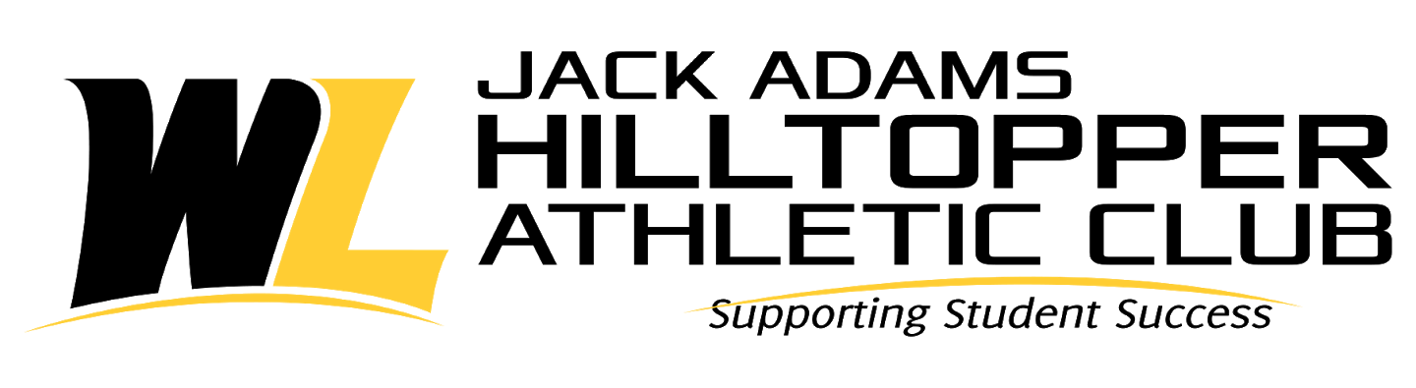

Online registration and payment can be made at:
wlufoundation.org/corporate or complete the following registration form and mail with check to address below.

_____ Championship Package - $2,500 ______ MVP Package- $1,000

_____ Black & Gold Package - $500

Contact Person: ______________________________________________________________
Company Name: _____________________________________________________________
Address: _____________________________________________________________________
Phone: ______________________________________________________________________
Email: ______________________________________________________________________

Please write on the memo line HAC and make check payable to WLU Foundation and mail with form to:

West Liberty University
208 University Drive CUB 126
West Liberty, WV 26074

If you have any questions, please contact Shawn Ullom at 304-336-5635 or shawn.ullom@westliberty.edu

