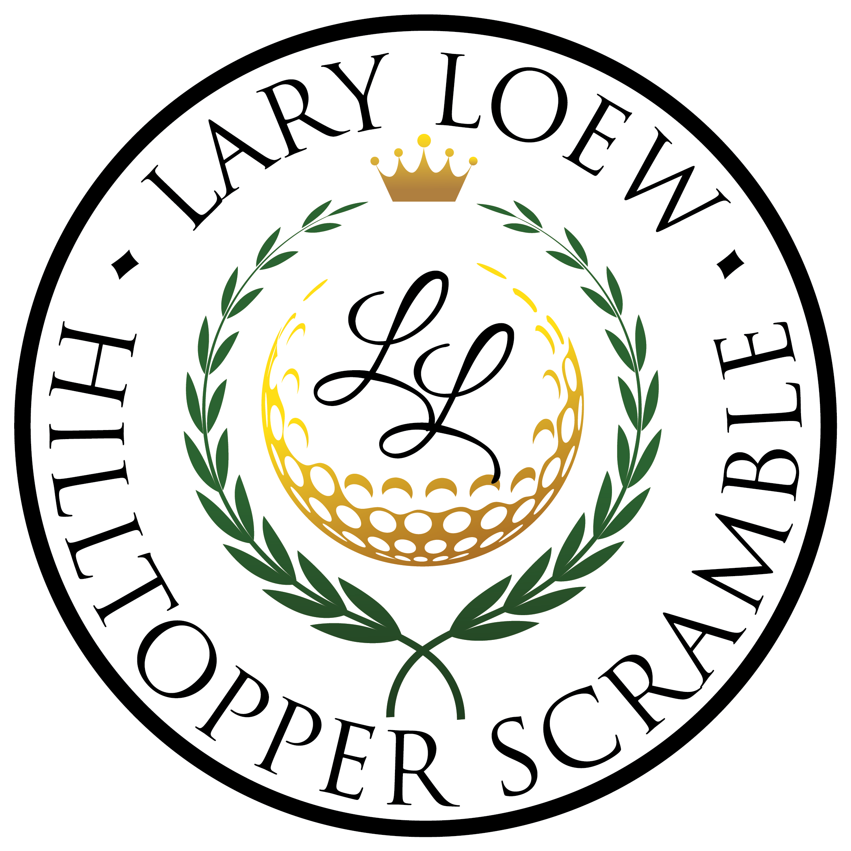
Annual Lary Loew Golf Scramble
Oglebay Resort – Arnold Palmer Course
Friday, June 21, 2024 – 1 p.m. Shotgun Start

Sponsorship Opportunities
Ace Sponsorship - $5,000 – (No longer available)
- 2 teams of four in the scramble
- Press release and photo-opt
- Signage at lunch and at three tee boxes
- Opportunity to promote business at lunch
- Company name and logo on printed, social, email and website ads
- 2 VIP season passes to the Charlie Annett Hospitality Box at West Family Stadium
- 8 additional tickets for employees/friends to the Charlie Annett Hospitality Box to one game of choice
- Opportunity to share your promotional materials in VIP area
- Custom promo activity at Football game
- Company recognition at all home Football and Basketball games
- Presence on Main Street Bank Video Board, and Topperstation.com (streaming platform)
- Banner with company logo displayed at West Family Stadium and the ASRC

Pro Level Sponsorship - Tiki Party Lunch - $1,500
Themed lunch sponsorship at Coach Waialae’s house, located between holes 3 & 4.
- 1 team of four in the scramble
- Signage at the lunch and at three tee boxes
- Opportunity to promote business at the lunch
- Company name promoted on printed, social, email, and website ads
- 2 VIP Passes to the Charlie Annett Hospitality Box at West Family Stadium for one home football game

Eagle Sponsorship - $1,000
- Signage at three tee boxes
- 1 team of four in the scramble
- 2 VIP Passes to the Charlie Annett Hospitality Box at West Family Stadium for one home football game

Hole-in-One Sponsorship - $500
- Signage at three tee boxes
- 2 VIP Passes to the Charlie Annett Hospitality Box at West Family Stadium for one home football game

Birdie Tee Box Sponsorship - $125
- Signage at one tee box

Team Only Participation
- 1 team of 4 - $500
*See reverse side to register as a sponsor

Online registration and payment can be made at:
http://www.wlufoundation.org/loewgolf
or complete the following registration form and mail with check to address below.

_____ Ace Level - $5,000 _____ Pro Level – Tiki Party Lunch -$1,500
_____ Eagle Level - $1,000 _____ Hole- in-One Level - $500
_____ Birdie Level - $125 _____ Team Only Participation - $500

Contact Person: ______________________________________________________________
Company Name: _____________________________________________________________
Address: ______________________________________________________________________
Phone: ________________________________________________________________________
Email: _________________________________________________________________________

Please make check payable to WLU Foundation and mail with form to:

West Liberty University
208 University Drive, C.U.B. 126
West Liberty, WV 26074

If you have any questions, please contact us at 304-336-5635.
- Please complete and mail back by June 14, 2024

